SOFT PUMPKIN COOKIES

INGREDIENTS
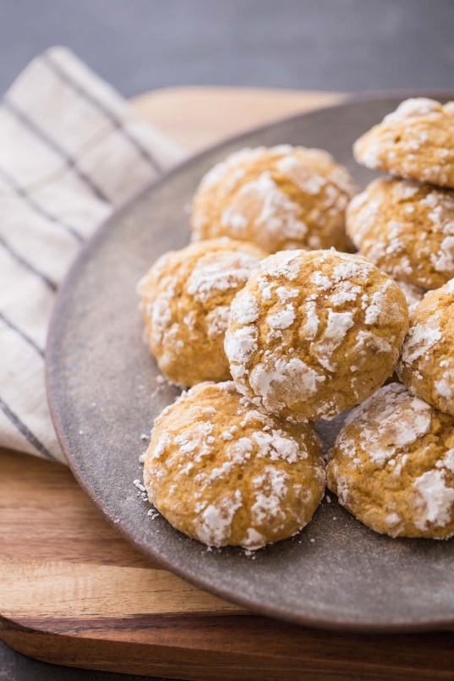
- 2 1/2 cups all-purpose flour
- 1 teaspoon baking soda
- 1 teaspoon baking powder
- 1 teaspoon cinnamon
- 1/2 teaspoon nutmeg
- 1/2 teaspoon salt
- 1 1/2 cups granulated sugar
- 1/2 cup butter, softened
- 1 cup pure pumpkin
- 1 egg
- 1 teaspoon vanilla extract
- 1 cup powdered sugar

INSTRUCTIONS
- Line baking sheets with parchment paper or spray with non-stick baking spray.
- Combine flour, baking soda, baking powder, cinnamon, nutmeg, and salt in a medium bowl.
- Beat sugar and butter with mixer on medium high speed, then blend in pumpkin, egg, and vanilla until incorporated.
- Gradually mix in flour and dry ingredients. Refrigerate dough for 3-4 hours.
- Preheat oven to 375 degrees.
- Scoop dough into one inch balls. Roll in powder sugar, place dough balls on baking sheet (12 per sheet) and bake for 11-13 minutes. Remove from baking sheet to a cooling rack. When completely cool, store cookies in an airtight container.

